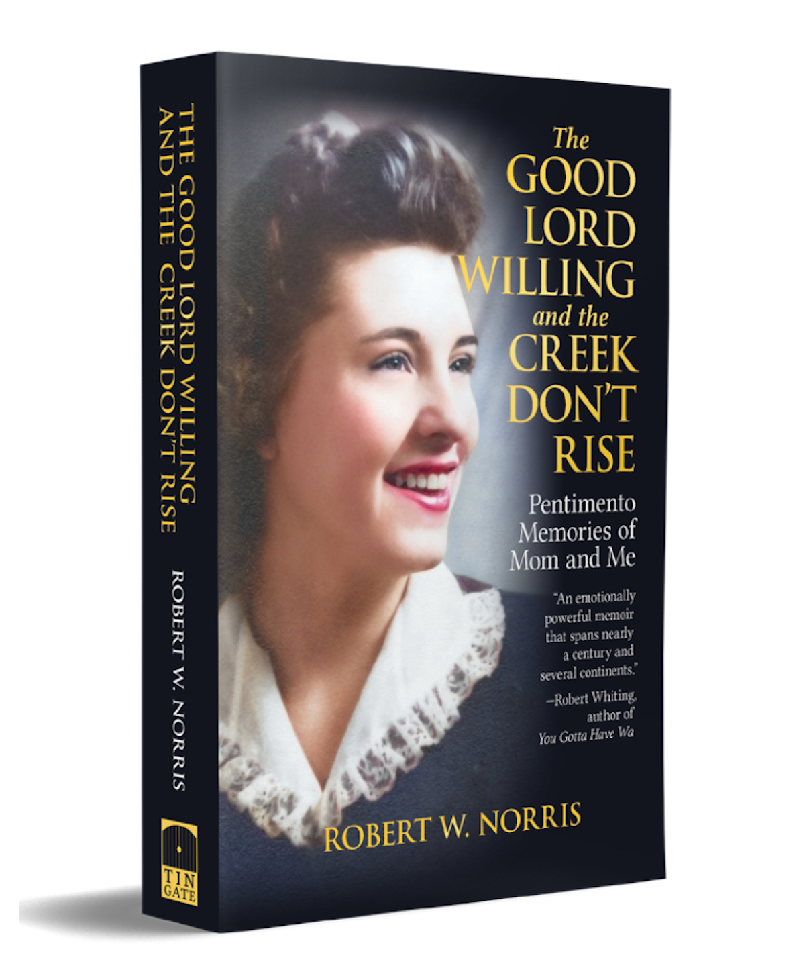

**The Good Lord Willing**

**and the Creek Don’t Rise**

Pentimento Memories of Mom and Me

AUTHOR: Robert W. Norris

**“An emotionally powerful memoir that spans nearly a century**

**and several continents.”**

**—Robert Whiting, author of *You Gotta Have Wa***

*The Good Lord Willing and the Creek Don’t Rise: Pentimento Memories of Mom and Me* traces the trials, tribulations, and unbreakable bond of two Pacific Northwest characters. Kay Schlinkman grows up on the banks of the Columbia River in the 1930s and 1940s. She overcomes a small logging town’s ostracism in the late 1950s for her divorce, excommunication by the Catholic Church for remarrying, severe criticism and rejection for defending her son’s refusal to go to war, and the burden of paying off her second husband’s gambling debts. She takes night classes to become qualified as a legal secretary in her fifties and continues to work until she’s seventy-eight.

Robert Norris goes to military prison as a conscientious objector to the Vietnam War, embraces the counterculture upon release, wanders the world in search of his identity, and eventually lands in Japan, where he finds his niche as a university professor, spends two years as the dean of students, and retires as a professor emeritus.

Despite their separation by the expanse of the Pacific Ocean, Robert and Kay maintain a lifelong commitment of love, respect, and support that enriches both their lives. This story provides a heart-warming example of how far a mother and son can go in maintaining their bond against all odds. A must read for all mothers and sons, and for those who’ve wondered what the road less traveled would’ve been like had they taken that first step.

**Advance Praise**

“Robert Norris’s deeply personal story of finding his conscience when ordered to Vietnam is told here with direct, powerful prose.”

—David Zeiger, documentary filmmaker, director of *Sir, No Sir*

“A wide-ranging, fascinating ramble of a tale that has you rooting for the characters every step of the way.”

—Rosa del Duca, author of *Breaking Cadence:*

*One Woman’s War Against the War*

“A sweeping epic of a memoir. Norris writes his vast narrative with clarity and

thoroughness.”

—Alan Samson, retired journalist and author of

*Me. And Me now: A 1970s’ Kiwi Hippie Trail Adventure*

**About the Author**

Robert W. Norris was born and raised in Humboldt County, California. He is the author of three novels, a novella, a memoir, and several research papers on teaching. He and his wife live near Fukuoka, Japan.

**Social media link (blog/site) # and @**

PAPERBACK

978-1-80100-000-0

490 pages

6 x 9 in (152 x 229 mm)

17 January 2023

$21.99

E-BOOK

978-1-80100-001-7

Mobi/ePub

17 January 2023

$6.99

KEYWORDS

Memoir; nonfiction; Vietnam War; conscientious objector, Hippie Trail; broken families; Japan; expatriate; international marriage; nomadic life; Columbia River history; culture shock; mothers and sons; family memoir; living abroad; independent women; family bonds; Irish roots; cross-cultural

SUBJECT

NON-FICTION

DBN Biography: General

DBNA Autobiography: General

DISTRIBUTION

US Ingram Book Group

UK Gardners Books

FURTHER INFORMATION

Published by Tin Gate

https://tingatebooks.com

Author website / email

https://robertwnorris.com

robert@robertwnorris.com