FOR IMMEDIATE RELEASE

Vietnam War Conscientious Objector Chronicles Life Journey,
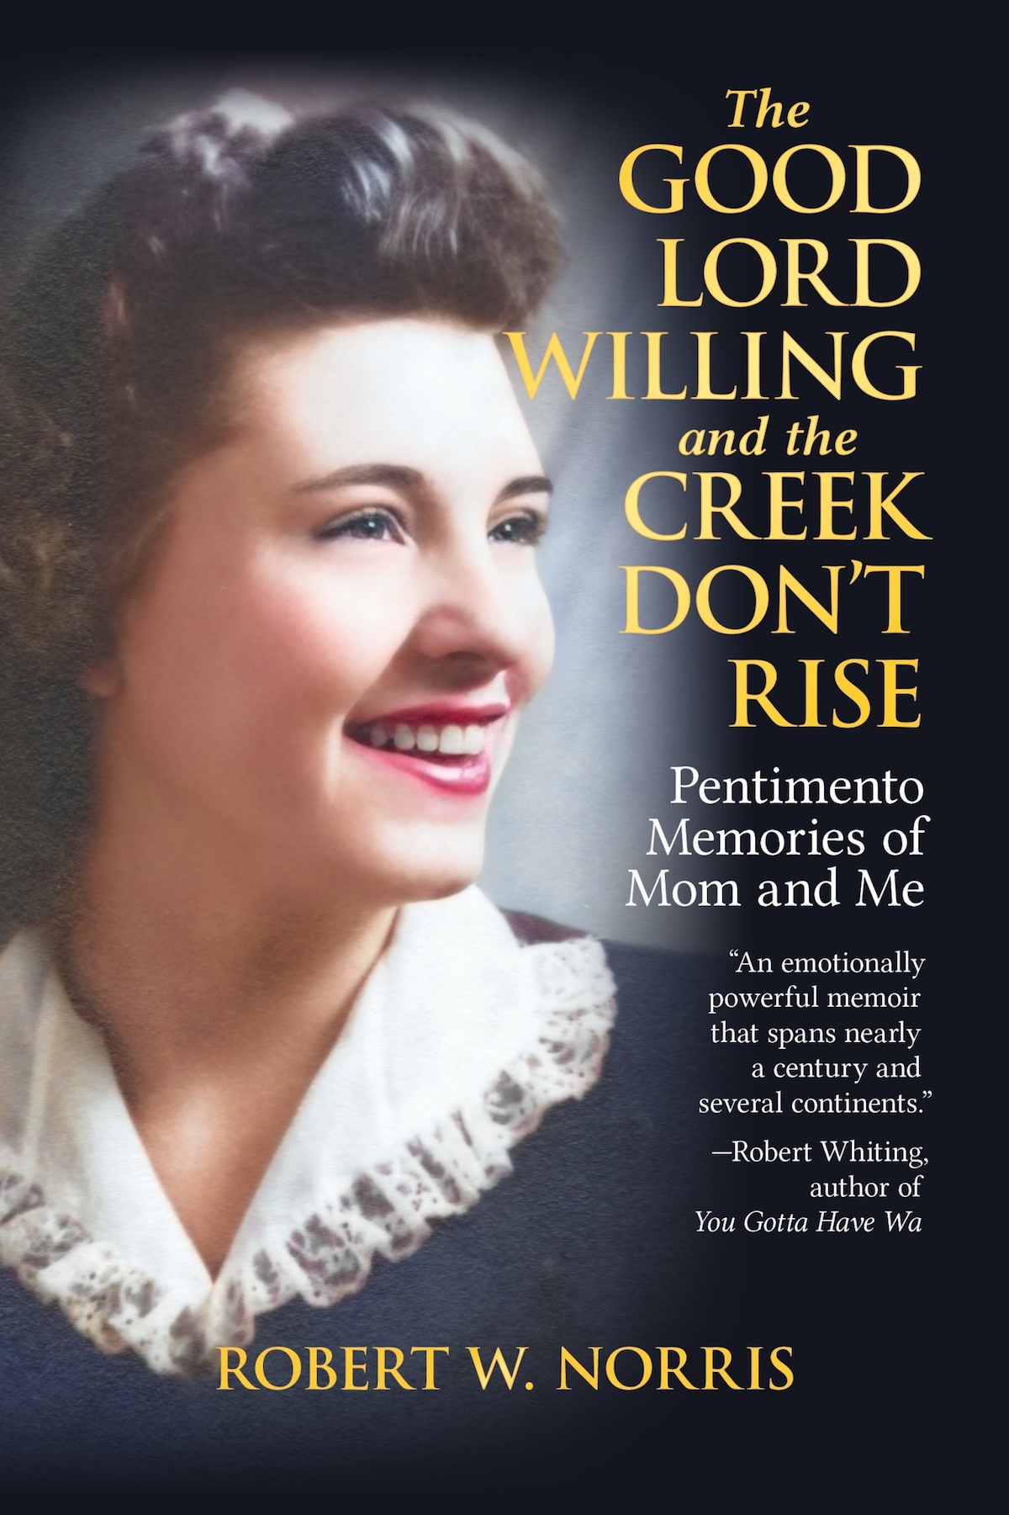
Pays Tribute to His Mother

FUKUOKA, JAPAN (Jan. 3, 2023) —Robert W. Norris—a Pacific Northwest native, Vietnam War conscientious objector, and long-time resident of Japan—has announced the publication of his life story, which he calls “a tribute to my mother.”

In The Good Lord Willing and the Creek Don't Rise: Pentimento Memories of Mom and Me (Tin Gate Books, 2023), Norris explores the separate life paths that he and his mother Kay traveled and the bond between them that was as constant as her unconditional love. The early chapters put the reader in Kay's shoes as she grows up during the Depression, marries young, rebels against her husband's controlling family, battles the Catholic Church authorities, remarries, and starts anew as a legal secretary in her forties.

The book then recounts how, after an idyllic childhood, Norris goes to military prison as a conscientious objector to the Vietnam War, embraces the counterculture upon release, wanders the world in search of his identity, and eventually lands in Japan, where he finds his niche as a university professor, spends two years as the dean of students, and retires as a professor emeritus.

Norris said, “My purpose in writing this story was to try to evoke the importance of family bonds in helping us overcome difficult times and to remind people not to be afraid of the unknown. I believe it’s a good book for not only mothers and sons but also for people who’ve wondered what the road less traveled would’ve been like had they just taken that first step. I hope readers come away from it with a positive feeling.”

Advance Praise

“Robert Norris’s deeply personal story of finding his conscience when ordered to Vietnam is told here with direct, powerful prose. An important, fascinating read.”—David Zeiger, documentary filmmaker, director of Sir, No Sir

“A wide-ranging, fascinating ramble of a tale that has you rooting for the characters every step of the way …. [It] invites you to reflect on American culture, family, duty, home, and what it means to live a full life.” —Rosa del Duca, author of Breaking Cadence: One Woman’s War Against the War

“A bumpy, coming-of-age tale set in the logging country of the Pacific Northwest, dosed with a mother’s love, transforms an alienated young man into an expat and ultimately an emeritus professor in Japan. Robert W. Norris crafts the stages of this extraordinary journey—punctuated with a turn as a Vietnam War resister—in a narrative style that is both graceful and seamless.”—Michael Uhl, author of Vietnam Awakening and The War I Survived was Vietnam

About the Author

Robert W. Norris was born and raised in Humboldt County, California. He was a conscientious objector to the Vietnam War and served time in a military prison for refusing his order to fight. In his twenties, he roamed across the United States, went to Europe twice, and made one journey around the world. In 1983, he landed in Japan, where he became a professor at a private university and retired as a professor emeritus. He is the author of three novels, a novella, and several research papers on teaching. He and his wife live near Fukuoka, Japan.

Book Information
The Good Lord Willing and the Creek Don't Rise:
Pentimento Memories of Mom and Me
by Robert W. Norris
Publisher and publication date: Tin Gate, January 17, 2023
ISBN: 978-1-80100-000-0 (6 x 9 paperback)
ISBN: 978-1-80100-001-7 (Mobi / ePub)
Pages: 490 / Price $21.99 (paperback); $6.99 (ebook)

Both Ebook and paperback available now for pre-order on Amazon.

Contact:
Robert W. Norris
Email: robert@robertwnorris.com
Website: robertwnorris.com

###

